Fallen officers honored in Auburn

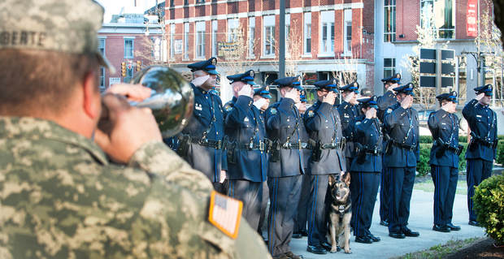
Russ Dillingham/Sun Journal
Police officers from the Auburn Police Department salute as taps is played by Scott Laliberte, left, of the Maine Army National Guard's 133rd Engineer Battalion. Wednesday night's celebration of National Police Week was held at the Auburn Fallen Officers Memorial on the corner of Court and Turner streets.

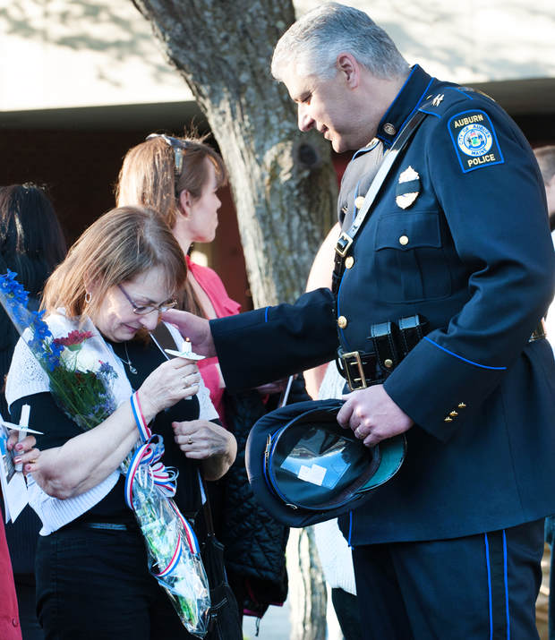
Russ Dillingham/Sun Journal
Auburn Police Chief Phil Crowell comforts Cherrie Bonney, widow of former Auburn police officer Rodney "Rocky" Bonney, who died in the line of duty in 1981.

Wednesday, May 13, 2015 at 9:26 pm
AUBURN — It's easy to think of the candles and bagpipes, prayers and flowers as mere ritual and routine. Then people start talking — memories are shared and condolences
"It's so nice," Cherrie Bonney said. "It's just nice to know that people don't forget."
Bonney is the widow of Rodney "Rocky" Bonney, the Auburn police officer who drowned in 1981 while trying to rescue a teenager from the Androscoggin River.
Each May, on National Police Week, Cherrie joins dozens of others who gather in Auburn to honor the police officers who have died in the line of duty. Each May, she finds comfort in the memories of others.
"It's so good to see this kind of turnout," she said, just as the bagpipes began a mournful song. "It seems to grow bigger every year."
Just before sunset Wednesday, dozens gathered at the Auburn Fallen Officers Memorial at Court and Turner streets. Some were rookie police officers who looked barely old enough to shave. Others were former cops, long retired. It's meant to be a somber affair but not a downright sad one.
"They have good reasons for doing all this," said Richard Valcourt, a former Auburn police officer who left the department in 1984.
Two of those reasons are obvious. There's Bonney and there's officer Norman Philbrick, who died July 7, 1949, when a pair of firetrucks collided at Court and Main streets. Philbrick had been directing traffic at the intersection as crews responded to a structure fire.
Philbrick's daughter, Gloria Porter, accepted flowers from a young officer as part of the service. Cherrie Bonney did the same. Farther back in the crowd, mingling, was John Perrino, the former Auburn officer who was also in the river the night Rocky Bonney perished.
"He'll never forget it," said Paulette Dingley, Perrino's longtime girlfriend. "Never. That was his partner."
Like the others, Perrino came out to show his respect for the fallen ones and to find comfort in familiar faces and old stories.
But while they paid tribute to their fallen comrades, they were also mindful of the officers still doing the job and still facing dangers every day. On average, one law enforcement officer is killed in the line of duty somewhere in the United States every 58 hours, according to government statistics.
In increasingly dangerous times, few are more aware of the perils of police work than the wife of an officer, present or former.
"I'm so glad he's not a police officer anymore," said Monette Valcourt, wife of the former Auburn cop. "Things have gotten so bad out there."
Tyler Ham, the Auburn department's K-9 officer — who named his police dog "Rocky" — reminded his fellow officers to keep these things in mind when facing dangers on the job. After all, he told them, it's not the officer's life alone that matters. It's also the well-being of husbands and wives, sons and daughters.
"There are so many people," Ham said, "who count on you to come home at the end of the day."

