How to Restore Windows Photo Viewer in Windows 10

Information
Usually you could use Windows Photo Viewer to view your image files in a variety of ways. You can also print, order prints, attach pictures to an e-mail message, burn, or open photos in another app on your PC.
Windows 10 uses the Photos app as the default app to open image files with instead now. By default, Windows Photo Viewer is no longer listed in Open with, and only has .tiff files associated with it in Default Programs.
This tutorial will show you how to restore Windows Photo Viewer to be able to select to open image files in Default apps, Default Programs, and Open with for only your account or all users in Windows 10.
CONTENTS:
  - Option One: To Only Restore Windows Photo Viewer for Current Account
  - Option Two: To Restore Windows Photo Viewer for All Accounts
EXAMPLE: Default and Restored Windows Photo Viewer

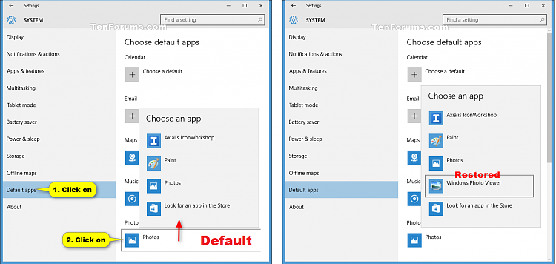
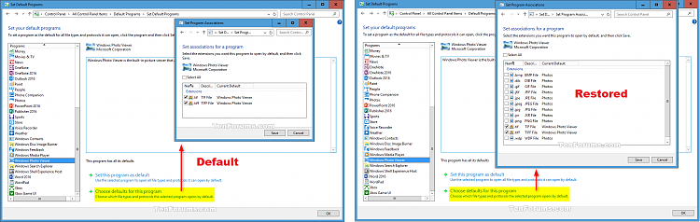
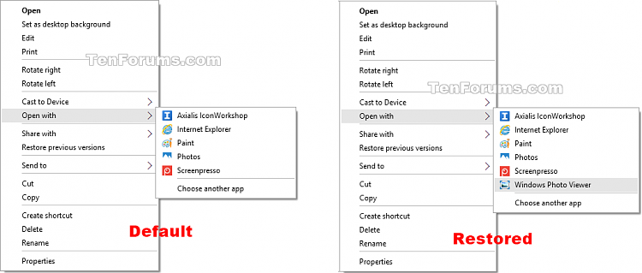
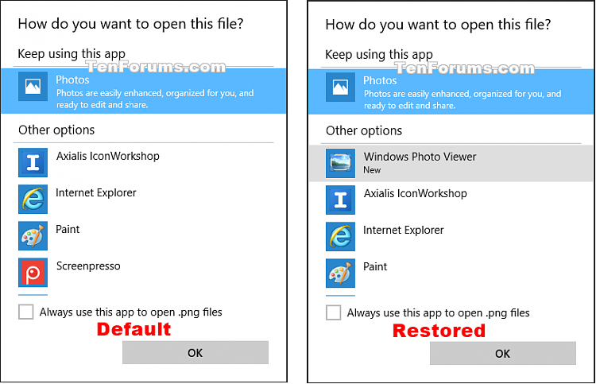
OPTION ONE
To Only Restore Windows Photo Viewer for Current Account

Note
This option will only affect the account that you are currently signed in to.
1. Do step 2 (restore) or step 3 (undo) below for what you would like to do.
2. To Restore Windows Photo Viewer for Only Your Account
A) Click/tap on the Download button below to download the file below, and go to step 4 below.
Restore_Windows_Photo_Viewer_CURRENT_USER.reg


3. To "Undo" Restore Windows Photo Viewer for Only Your Account
NOTE: This is the default setting.
A) Click/tap on the Download button below to download the file below, and go to step 4 below.
Undo_Restore_Windows_Photo_Viewer_CURRENT_USER.reg
4. Save the .reg file to your desktop.
5. Double click/tap on the downloaded .reg file to merge it.
6. If prompted, click on Run, Yes (UAC), Yes, and OK to approve the merge.
7. You can now delete the downloaded .reg file if you like.
8. If you selected to undo restore Windows Photo Viewer, then select a different app (ex: Photos) as the default app under Photo viewer in Settings. (see screenshot below step 9)
9. If you selected to restore Windows Photo Viewer, then select "Windows Photo Viewer" as the default app under Photo viewer in Settings. (see screenshot below)
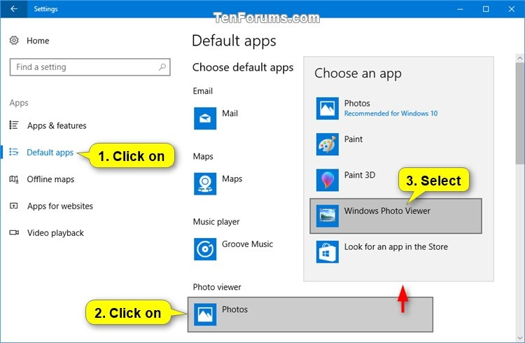

OPTION TWO
To Restore Windows Photo Viewer for All Accounts

Note
You must be signed in as an administrator to be able to restore Windows Photo Viewer using this option.
This option will override Option One above.
1. Do step 2, step 3, or step 4 below for what you would like to do.
2. To Restore Windows Photo Viewer for All Users
A) Click/tap on the Download button below to download the file below, and go to step 5 below.
Restore_Windows_Photo_Viewer_ALL_USERS.reg

3. To Restore Windows Photo Viewer for All Users with Sort Order Fix

Note
This option does the same as step 2 above, but allows you to view files in the same order that you arranged them in.
This option does cause Windows Photo Viewer to be listed twice in Open with -> Choose an app.
A) Click/tap on the Download button below to download the file below, and go to step 5 below.
Restore_Windows_Photo_Viewer_ALL_USERS_with_Sort_order_fix.reg

4. To "Undo" Restore Windows Photo Viewer for All Users
NOTE: This is the default setting.
A) Click/tap on the Download button below to download the file below, and go to step 5 below.
Undo_Restore_Windows_Photo_Viewer_ALL_USERS.reg
5. Save the .reg file to your desktop.
6. Double click/tap on the downloaded .reg file to merge it.
7. If prompted, click on Run, Yes (UAC), Yes, and OK to approve the merge.
8. You can now delete the downloaded .reg file if you like.
9. If you restored Windows Photo Viewer, then set this program as default for your account. Other users on the PC will also need to do this step if they want Windows Photo Viewer set as the default program in their account.
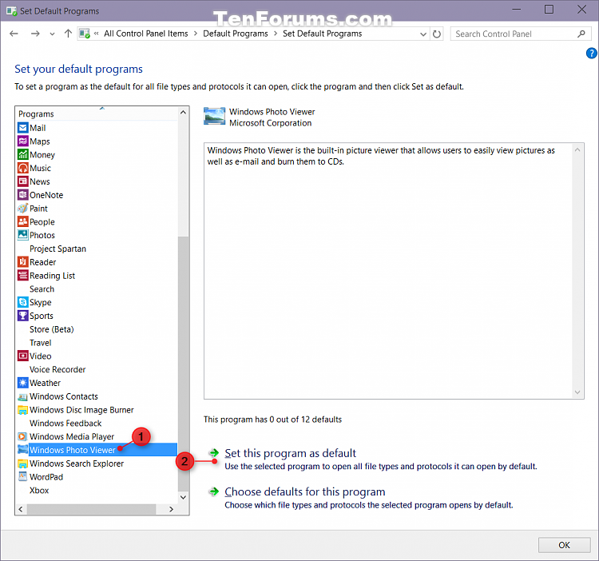
That's it,
Shawn

