Your Start Menu Isn’t Working

[December 24, 2015](http://configmgr.com/critical-error-your-start-menu-isnt-working/) [0 Comments](http://configmgr.com/critical-error-your-start-menu-isnt-working/#disqus_thread) Written by [**Anthony Clendenen**](http://configmgr.com/author/bm-s0ncr/)

I have been working on a post regarding DRS the last couple days and only had to test some custom SQL before finishing it but this morning I ran into this…

[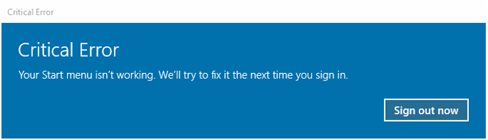](http://configmgr.com/critical-error-your-start-menu-isnt-working/critical-error-start-menu/)

Critical Error

This was the result of clicking on the start button in Windows 10 build 1511.

Seems I am not alone, and the culprit seems to be **Dropbox** at least those are the rumors ([here](https://answers.microsoft.com/en-us/windows/forum/windows_10-start/windows-10-critical-error-start-menu-isnt-working/878cdf28-aae2-4b93-9dbf-aef0bc9ab0ea?page=1) and [here](http://news.softpedia.com/news/how-to-easily-fix-windows-10-start-menu-and-cortana-critical-error-496065.shtml)).  I recently reinstalled DB on my PC, maybe a week or two ago so that seemed reasonable.  I uninstalled DB, rebooted, but no joy, same issue.

In the Microsoft forums a [Microsoft Support Engineer](https://answers.microsoft.com/en-us/profile/d6c29b45-e520-4236-addb-c2aaf20b762a) suggested this and it seemed to work for quite a few people.

“Please follow the below steps and check if it helps in resolving the issue.

1. Open the **Task manager**. Here’s a tip: Press **CTRL+Shift+ESC**.
2. Click **File** > **Run New Task**.
3. Make sure you have a check mark beside “**Create this task with administrative privileges**”.
4. Type **CMD**.
5. Type the following 4 commands at the CMD prompt:

**dism /online /cleanup-image /restorehealth**

**sfc /scannow**

**powershell**

**Get-AppXPackage -AllUsers |Where-Object {$_.InstallLocation -like “*SystemApps*”} | Foreach {Add-AppxPackage -DisableDevelopmentMode -Register “$($_.InstallLocation)\AppXManifest.xml”}**

1. Close the **CMD** window.”

Not for me though.  I was getting “**Error: 0x800f081f**” or “**The source files could not be found**” when I ran the DISM command “**dism /online /cleanup-image /restorehealth”**

Seems the source files were corrupt so here is how I got it work.

**Note**: You will need your Windows 10 installation source, I have an ISO but a DVD, USB key, or the extracted files on a disk works just as well.

1. **Open PowerShell or command prompt as an administrator**.  Since you can’t use the start menu, you can either right click on the start menu and select Command Prompt (Admin) or use good old Ctrl-Alt-Del, open Task Manager, select File, Run new task, check the check box to create with admin rights and type PowerShell (see below).[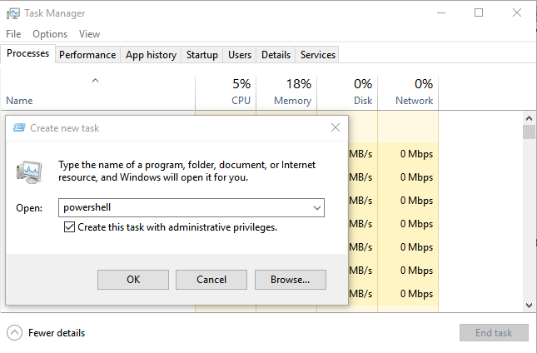](http://configmgr.com/critical-error-your-start-menu-isnt-working/task-manager-run/)

2. Either insert it into your Windows 10 installation disk into your DVD drive or if you have the ISO, simply right click on it and choose Mount from the menu.  **Note the drive letter where your Windows 10 bits are now.**

3. Replace the **X** in the command below with your own drive letter noted from step 2 and then copy and paste this into your your cmd prompt or PowerShell window and hit enter.

**DISM /Online /Cleanup-Image /RestoreHealth /source:WIM:X:\Sources\Install.wim:1 /LimitAccess**

Instead of it sitting at 20% you should see it slowly progress and it should complete after several minutes.

Since you have a few minutes…This is the same command from above that errors out **dism /online /cleanup-image /restorehealth**vs.**DISM /Online /Cleanup-Image /RestoreHealth**, we just **add the source location** to tell DISM where to find our **Install.wim** file by adding **/source:WIM:X:\Sources\Install.wim:1**, and the **/LimitAccess** at the end tells DISM not to try and get the files from Windows Update so we don’t waste that time waiting.

4. Once that completes successfully, using the same window, **run this command** to repair any damaged system files.

**/sfc scannow**

5.  After that completes you can close the window and **reboot**.

After you reboot your start menu and Cortana should be working again.  I did not need to run the last command suggested by the Support Engineer or the one he suggested after his solution.  Get-AppXPackage installs a package but wasn’t needed in my case.  Hopefully it continues to work as some have reported that it seems to come back.

Good luck!

**Your error may look like one of these:**

Critical Error  
Your start menu is damaged. We will try to fix it on start up.

Critical Error  
Your Start Menu isn’t working. We’ll try to fix it the next time you sign in.

Critical Error  
Start menu and Cortana aren’t working. We’ll try to fix it the next time you sign in.

**And in event viewer you may see these events:**

Activation of app Microsoft.**Windows.ShellExperienceHost**_cw5n1h2txyewy!App failed with error: This app does not support the contract specified or is not installed. See the Microsoft-Windows-TWinUI/Operational log for additional information.

**Event ID 5973**

 Activation of app Microsoft.**Windows.Cortana_cw5n1h2txyewy!CortanaUI** failed with error: This app does not support the contract specified or is not installed. See the Microsoft-Windows-TWinUI/Operational log for additional information

**Event ID 5973**