**How to install CAB and MSU updates in Windows 10**

One of the frequently asked questions by Winaero readers is how do you install an offline (downloaded) update in Windows 10? Usually, with Windows 10 version update announcements, I try to provide direct links to update files. Cumulative standalone updates for Windows 10 have the MSU format. Here is how you can install an update which comes as a CAB or MSU file.  
  
[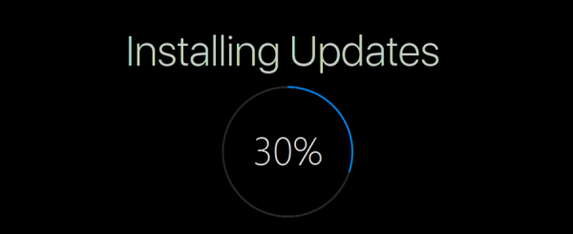](http://winaero.com/blog/wp-content/uploads/2016/07/Windows-10-install-update-banner.png)  
If you manually downloaded updates for Windows 10, for example, the recently released Windows 10 KB 3189866 you get a file named windows10.0-kb3189866-x64_2c3e91a8162269579c8bf26a502c620d41efef0d.msu

Let's assume that you moved it to the folder C:\updates.

To apply this update to the installed and running operating system, do the following:

**How to install an MSU update in Windows 10**

1. Open an elevated command prompt.
2. Type the following command:

wusa.exe "c:\updates\windows10.0-kb3189866-x64_2c3e91a8162269579c8bf26a502c620d41efef0d.msu

Correct the path to the update to match your file location.

**How to install a CAB update in Windows 10**

If your update comes as a file with the CAB extension, you need to use another command to install it.

Before you continue, you might be interested in reading the following article:

[**Context menu to install CAB updates in Windows 10**](http://winaero.com/blog/context-menu-to-install-cab-updates-in-windows-10/)

1. Open an elevated command prompt.
2. Type the following command:

dism /online /add-package /packagepath:"C:\update\cabname.cab"

Again, correct the path to the update to match your file location.

These command line methods are useful for batch files, that is, when you want to install a group of updates at once. Normally, if your file associations are not messed up, MSU files can be double clicked and installed easily but the command line method allows automating the process. With WUSA.exe, you can also use switches like /quiet, /norestart etc.

Note: MUI (langauge packs) often have the CAB format. But you should not use the DISM command to install them. Instead, run the built-in *lpksetup.exe* tool and follow the wizard's instructions.  
You can learn in detail how to use lpksetup.exe from the following article: [How to install an MUI language CAB file in Windows 10](http://winaero.com/blog/how-to-install-an-mui-language-cab-file-in-windows-10/).