How to Rebuild the Icon Cache in Windows 10

Information
The icons that display for files in Windows are saved in an icon cache so they can be displayed quickly instead of having to manually scan and slowly load them each time.
The icon cache can sometimes become corrupted causing the icons of files to display incorrectly or distorted. When this happens, the icon cache needs to be deleted to reset and automatically recreate it.
This tutorial will show you how to rebuild the icon cache to clear and reset it for your account in Windows 10.
Note
Rebuilding the icon cache will not help with the following icon issues:
  - The icon of a shortcut not displaying properly due to the target source of the shortcut was moved or deleted. You may need to recreate a new shortcut directly from the source (ex: program's exe) file to replace it instead.
  - All icons for a specific file extension display the wrong icon. This may be due to setting the wrong association for what app to open the file type instead. If so, restoring the default association of the file extension will fix this issue.
  - Thumbnails of folders, pictures, videos, and documents.

CONTENTS:
  - Option One: To Rebuild the Icon Cache using a BAT file
  - Option Two: To Rebuild the Icon Cache in the Command Prompt

OPTION ONE
To Rebuild the Icon Cache using a BAT file
1. Click/tap on the download button below to download the file below.
Rebuild_Icon_Cache.bat

2. Save the .bat file to your desktop.
3. Close and save anything that you are working on before proceeding. The next steps will involve killing explorer and restarting the PC.
4. Run the .bat file.
5. If prompted, click/tap on Run to approve. If you like, you can unblock the .bat file to no longer get the Run (Open File - Security Warning) prompt. (see screenshot below)
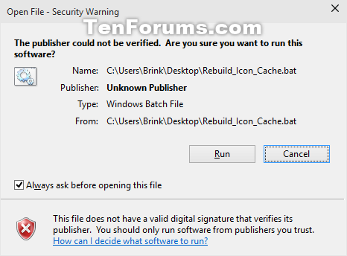
6. Follow the instructions in the command prompt to rebuild the icon cache. If you do not restart the PC now, you will need to later to finish rebuilding the icon cache. (see screenshots below)
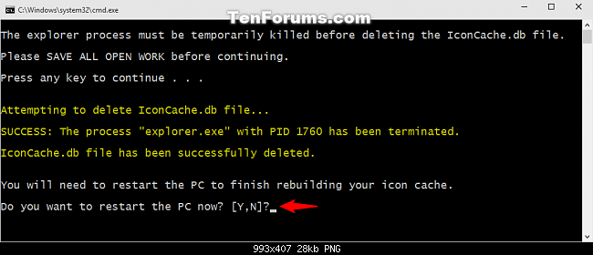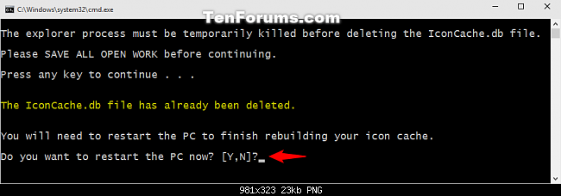
7. If the icons are still not displaying properly after rebuilding the icon cache, then download and merge the .reg file for the .ico (ICO) option here to restore the default associations of .ico (icon) files in Windows 10.

OPTION TWO
To Rebuild the Icon Cache in the Command Prompt
1. Close and save anything that you are working on before proceeding. The next steps will involve killing explorer and restarting the PC.
2. Open a command prompt.
3. Copy and paste each command below one at a time into the command prompt, and press Enter after each command.
Warning
The last command will instantly restart the PC.
ie4uinit.exe -show
taskkill /IM explorer.exe /F
DEL /A /Q "%localappdata%\IconCache.db"
DEL /A /F /Q "%localappdata%\Microsoft\Windows\Explorer\iconcache*"
shutdown /r /f /t 00
4. If the icons are still not displaying properly after rebuilding the icon cache, then download and merge the .reg file for the .ico (ICO) option here to restore the default associations of .ico (icon) files in Windows 10.

