How to Fix a Corrupt User Profile in Windows 10

Unfortunately, corrupt user files are common in Windows, especially after the upgrade from Windows 8.1/7 to Windows 10, and various solutions for this problem could be applied, depending on the situation and error message you receive. Users say that user profile can become corrupted because a lot of things, so we don’t know exactly what caused this problem to you. So, we’re going to show you how to ‘revive’ your user profile, or if it’s not possible, how to create a new user profile and then transfer your files from the old one.

Solution 1 – Repair a Corrupt User Profile

Before we show you what to do here, we highly advise you to crate a backup of your hard disk, or just files you don’t want to lose, before trying anything which involves messing with the Windows Registry, because some people have reported that they’ve lost files by using this method, and we don’t want it to happen to you, as well.

**For various PC problems, we recommend to use this tool**.

This tool will repair most computer errors, protect you from file loss, malware, hardware failure and optimize your PC for maximum performance. Quickly fix PC issues and prevent others from happening with this software:

1. Download [**ReimagePlus**](http://www.reimageplus.com/includes/router_land.php?tracking=ReimageNetworkCon&dis=med&exec=run&lpx=rvb&banner=Guyava&adgroup=med&ads_name=DD) (100% safe download and endorsed by us).
2. Click **“Start Scan”** to find Windows issues that could be causing PC problems.
3. Click **“Repair All”** to fix all issues.

If cannot login to your user profile on startup, try to restart your computer first, as it probably doesn’t work, restart it again, and enter the [Safe Mode](https://www.google.rs/#q=site:wind8apps.com+safe+mode). Once you enter the Safe Mode, do the following:

1. Go to Search, type regedit and open Registry Editor
2. When Registry Editor launches, navigate to the following key:  
   HKEY_LOCAL_MACHINE\SOFTWARE\Microsoft\Windows NT\CurrentVersion\ProfileList
3. Click each S-1-5 folder and double-click the ProfileImagePath entry to find out which user account it relates to. (If your folder name ends with .bak or .ba follow [Microsoft’s instructions to rename them](https://support.microsoft.com/en-us/kb/947215))
4. Once you have determined where is the corrupt user profile(and it doesn’t have a .bak ending), double-click RefCount and change the Value data to 0 and click OK[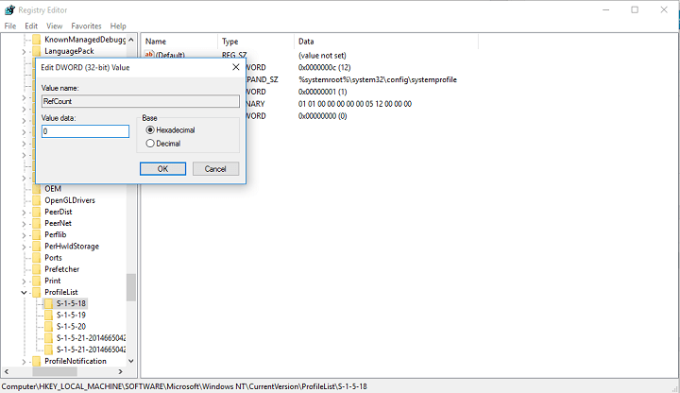](http://cdn.windowsreport.com/wp-content/uploads/2015/10/corrupted-user-account-problem.png)
5. Now double-click on State,make sure the Value data is again 0 and click OK
6. Close Registry Editor and restart your PC

We hope this solution helped you to restore your user profile, if not, you can try with creating a new one, and then transfer your files from the the previous account.

Solution 2 – Create a new user profile

If you cannot login to your user account on startup, the only thing you can do is to create a new account, and then transfer files from your corrupt account. If you already have another account registered on your computer, login with that account, and follow the steps for copying files from one account to another, as shown below. If you don’t have another account, you’ll have to enable special ‘hidden admin account’, and then login to that account to create a new user account, and transfer files from your old user profile.

Here’s how to enable hidden admin account:

1. Restart your computer and boot into Safe Mode
2. Open Command Prompt (by right-clicking on the Start Menu button, and choosing Command Prompt Admin))
3. Type in the following command and press Enter:
   * *net user administrator /active:yes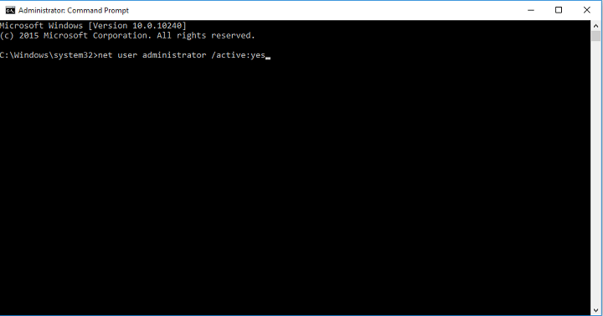*
4. You should get “The command completed successfully” message. Reboot your computer

You have activated the admin account, and it will be available to login on the next boot. So, when your computer starts, just login into the admin account and follow the steps below,  to create a new user profile:

1. Go to Settings, and then to Accounts
2. Go to Family and other users
3. Click on Add someone else to this computer[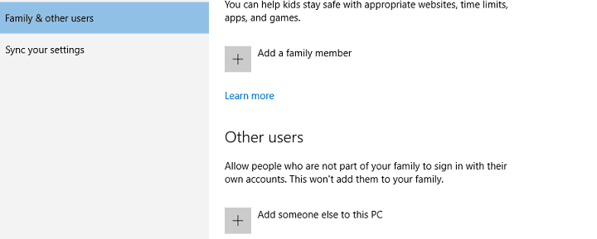](http://cdn.windowsreport.com/wp-content/uploads/2015/10/corrupted-user-account-problem-windows10.png)
4. Follow the instructions and finish the creation of new users profile

Now, you have a fully-function new user account, and all you have to do is to transfer your data from the old users account to it. And here’s how to do that:

1. Restart your computer, and login to the admin account again (it’s better to use this account, than account you just created)
2. Navigate to the corrupt user account (it’s on the disk you have Windows installed on (usually C:), under Users)
3. Open your corrupted user profile and copy content form it to your new user profile (if you have any problems with permissions, check out [this article](http://wind8apps.com/cant-delete-files-folders-icons-windows-10/))[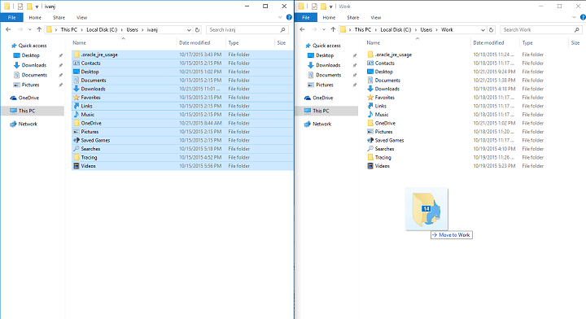](http://cdn.windowsreport.com/wp-content/uploads/2015/10/corrupted-user-account-problem-wind10.png)
4. Once everything is done, logout from your admin account, and log back in to the new account, and your settings should be transferred)

That would be all, if you have any comments, questions, or suggestions, just write them down in the comments section, below.

**Read Also:** [**Notepad Gets Improved in Windows 10 Through KB3103470 Update File**](http://wind8apps.com/notepad-windows-10-updates/)