**How to Clear and Reset Thumbnail Cache in Windows**

***information   Information***

By default, Windows stores the images for thumbnail previews in cache memory so that it can redisplay the images quickly each time you reopen a folder in Windows Explorer (Vista and Windows 7) or File Explorer (Windows 8).  
  
This tutorial will show you how you to clear and reset the [**thumbnail cache**](http://en.wikipedia.org/wiki/Windows_thumbnail_cache) to force **Windows** to reload the thumbnail picture views into the cache again as needed as you open folders.

***Note   Note***

The thumbnail cache **.db** files are located in the [**hidden**](http://www.sevenforums.com/tutorials/394-hidden-files-folders-show-hide.html) system folder location below:  
  
**C:\Users\User-Name\AppData\Local\Microsoft\Windows\Explorer**  
  
You may want to clear the thumbnail cache if the Windows Explorer thumbnail pictures have become corrupted and not displaying properly, or the thumbnail cache file has become to large and you want to clear some hard disk space.

**CONTENTS:**

* [**Option One:**](http://www.sevenforums.com/tutorials/10797-thumbnail-cache-clear-reset.html#option1) To Clear and Reset Thumbnail Cache using Disk Cleanup
* [**Option Two:**](http://www.sevenforums.com/tutorials/10797-thumbnail-cache-clear-reset.html#option2) To Clear and Reset Thumbnail Cache using a BAT File

**Thumbnail Cache - Clear and ResetOPTION ONE Thumbnail Cache - Clear and Reset**

**To Clear and Reset Thumbnail Cache using Disk Cleanup**

**1.** Open [**Disk Cleanup**](http://www.sevenforums.com/tutorials/818-disk-cleanup-open-use.html).  
  
**2.** Check the **Thumbnails** box, and click/tap on **OK**. (see screenshot below)

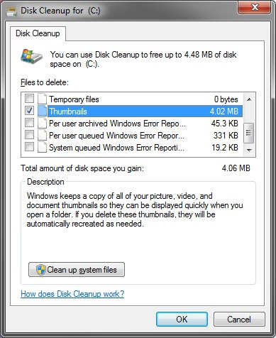

**3.** Click/tap on the **Delete Files** button. (See screenshot below)

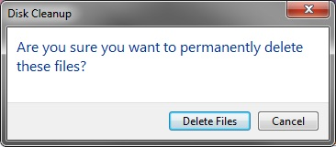

**4.** Disk Cleanup will now clear the thumbnail cache and close.

**Thumbnail Cache - Clear and ResetOPTION TWO Thumbnail Cache - Clear and Reset**

**To Clear and Reset Thumbnail Cache using a BAT File**

**1.** Click on the Download button below to download the BAT file below.

**Clear_and_Reset_Thumbnail_Cache.bat**  
  
[download](http://www.sevenforums.com/attachments/tutorials/357581d1430228180-thumbnail-cache-clear-reset-clear_and_reset_thumbnail_cache.bat)

**2.** **Save** the **.bat** file to your desktop.  
  
**3.** Run the .bat file.   
  
**4.** If prompted, click on **Run**.   
**NOTE:** *If you like, you can stop getting the Run prompt by* [***unblocking***](http://www.sevenforums.com/tutorials/124367-open-file-security-warning-unblock-file.html) *the downloaded .bat file*.  
  
**5.** Follow the instructions in the command prompt to clear and reset your thumbnail cache.

[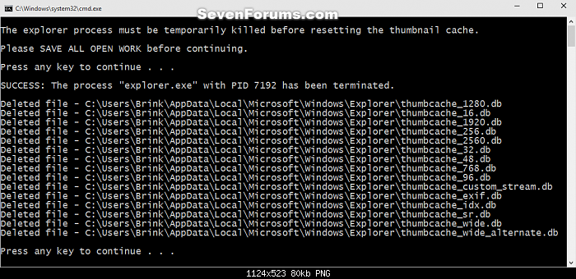](http://www.sevenforums.com/attachments/tutorials/357582d1430228327-thumbnail-cache-clear-reset-reset_thumbnail_cache_command.png)

That's it,