How to Create a 'Clear Clipboard' Shortcut in Windows 10

Information
The clipboard is a temporary storage area used by Windows. Information (such as text, files, graphics, sound, or video) can be copied to the clipboard from one program or location and pasted elsewhere. The clipboard can only hold one piece of information at a time. Whenever something is copied to the clipboard, it automatically replaces whatever was there before.
This tutorial will show you how to create or download a Clear Clipboard shortcut that will allow you to clear the contents of your clipboard as needed in Windows 10.
Note
When you click/tap on the Clear Clipboard shortcut, a command prompt window will quickly open and close to indicate that it has cleared the contents of your clipboard.
CONTENTS:
  - Option One: To Download a "Clear Clipboard" Shortcut
  - Option Two: To Manually Create a "Clear Clipboard" Shortcut

OPTION ONE
To Download a "Clear Clipboard" Shortcut
1. Click/tap on the Download button below to download the .zip file below.
Clear_Clipboard_shortcut.zip

2. Save the .zip file to your desktop.
3. Unblock the .zip file..
4. Open the .zip file, and extract (drag and drop) the shortcut to your desktop.
5. If you like, you can Pin to Taskbar, Pin to Start, add to All apps, add to Quick Launch, assign a keyboard shortcut to, or move this shortcut to where you like for easy use.
6. When finished, you can delete the downloaded .zip file if you like.

OPTION TWO
To Manually Create a "Clear Clipboard" Shortcut
1. Right click or press and hold on an empty area on your desktop, and click/tap on New and Shortcut.
2. Copy and paste the location below into the location area, and click/tap on Next. (see screenshot below)
%windir%\System32\cmd.exe /c "echo off | clip"
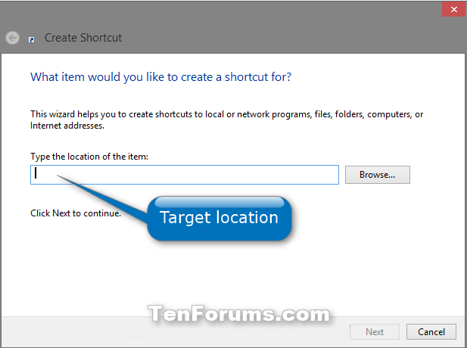
3. Type Clear Clipboard for the name, and click/tap on the Finish button. (see screenshot below)
NOTE: You could name this shortcut anything you would like though.
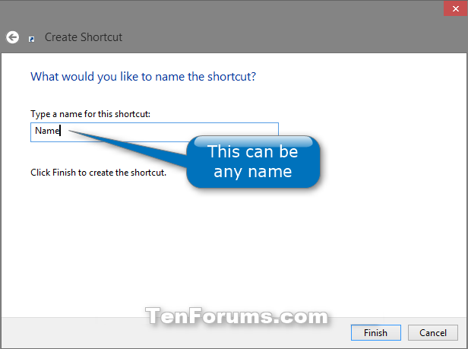
4. Right click or press and hold on the new Clear Clipboard shortcut, and click/tap on Properties.
5. Click/tap on the Shortcut tab, then click/tap on the Change Icon button. (see screenshot below)
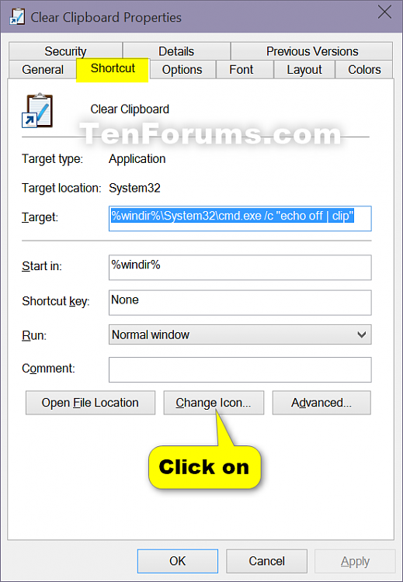
6. In the line under "Look for icons in this file", copy and paste the location below, and press Enter. (see screenshot below)
%windir%\System32\DxpTaskSync.dll
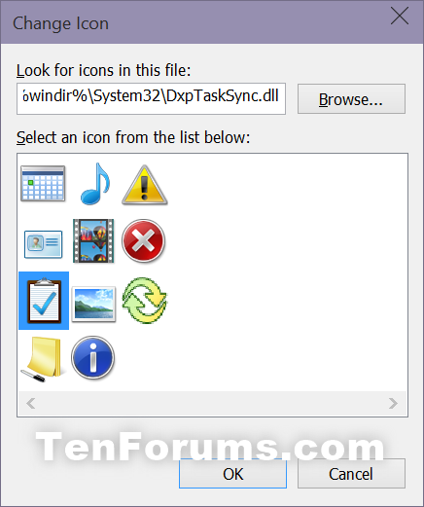
7. Select the icon highlighted in blue above, and click/tap on OK. (see screenshot above)
NOTE: You could use any icon that you would like instead though.
8. Click/tap on OK. (see screenshot below step 5)
9. If you like, you can Pin to Taskbar, Pin to Start, add to All apps, add to Quick Launch, assign a keyboard shortcut to, or move this shortcut to where you like for easy use.
That's it,

