Host file Editing

The Windows Hosts file allows you to define which domain names (websites) are linked to which IP addresses. It takes precedence over your [**DNS servers**](http://www.makeuseof.com/tag/change-dns-servers-improve-internet-security/), so your DNS servers may say *facebook.com* is linked to a specific IP address, but you can have *facebook.com* go anywhere you want. The Windows Hosts file can be used to block websites, redirect them, create shortcuts to websites, create your own local domains, and more.[**How To Change Your DNS Servers & Improve Internet Security**](http://www.makeuseof.com/tag/change-dns-servers-improve-internet-security/) [**How To Change Your DNS Servers & Improve Internet Security**](http://www.makeuseof.com/tag/change-dns-servers-improve-internet-security/)Imagine this - you wake up one beautiful morning, pour yourself a cup of coffee, and then sit down at your computer to get started with your work for the day. Before you actually get...[**Read More**](http://www.makeuseof.com/tag/change-dns-servers-improve-internet-security/)

We’ve previously covered [**using the Windows Hosts file to block websites without installing any other software on your computer**](http://www.makeuseof.com/tag/block-unsafe-websites-blocking-lists-windows-hosts-file/) – it’s often used for quick [**website blocking**](http://www.makeuseof.com/tag/block-inappropriate-websites-with-opendnss-familyshield-service/) by geeks in the know.

**Editing the Windows Hosts File**

To edit your Hosts file, you’ll need to open Notepad (or any other text editor you like, such as [**Notepad++**](http://www.makeuseof.com/tag/3-handy-builtin-notepad-features-beginners-windows/)) as Administrator. To do so, click *Start,* type *Notepad* into the Start menu, right-click the Notepad shortcut and select *Run as Administrator*.[**3 Handy Built-In Notepad++ Features For Beginners [Windows]**](http://www.makeuseof.com/tag/3-handy-builtin-notepad-features-beginners-windows/) [**3 Handy Built-In Notepad++ Features For Beginners [Windows]**](http://www.makeuseof.com/tag/3-handy-builtin-notepad-features-beginners-windows/)This summer, I’ve used Notepad++ for my internship quite a bit, so I can see why almost all developers and programmers I know actually prefer it, not to mention, the thousand of Notepad++ fans that...[**Read More**](http://www.makeuseof.com/tag/3-handy-builtin-notepad-features-beginners-windows/)

After you have, click *File* and *Open* in the Notepad window, then browse to the *C:\Windows\System32\drivers\etc* folder. Click the *Text Files* box at the bottom right corner of the window, select *All Files*, and double-click the hosts file.

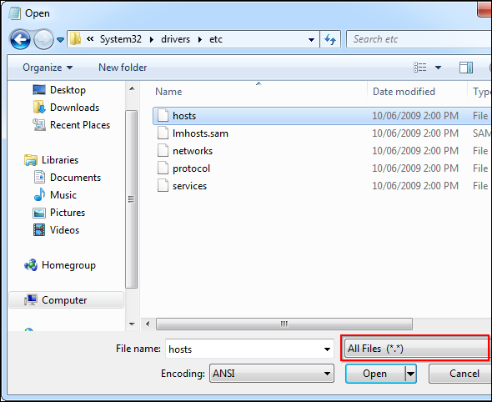

Changes you make to the hosts file will take effect immediately after you save the file – you don’t have to reboot. If you’re adding multiple entries to your hosts file, ensure each is on its own line.

[Ads by Google](https://support.google.com/adsense/troubleshooter/1631343?url=http%3A%2F%2Fwww.makeuseof.com%2Ftag%2F6-surprising-uses-for-the-windows-hosts-file%2F&client=ca-pub-9894449314507324)

**Block a Website**

To block a website, add a line like the following one to the bottom of the hosts file:

***127.0.0.1 example.com***

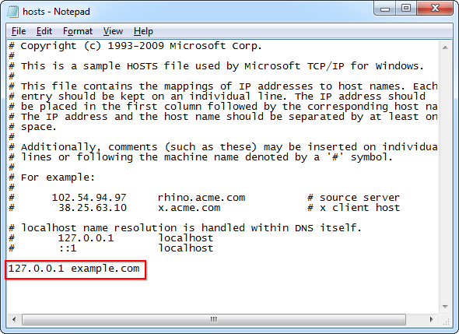

What this does is simple – 127.0.0.1 is the IP address’ of your local computer. When you navigate to example.com, your computer will try to connect to itself (127.0.0.1). Your computer probably won’t find a [**web server**](http://www.bluehost.com/track/muo/) running on itself, so the connection will fail immediately, effectively blocking the website from loading.

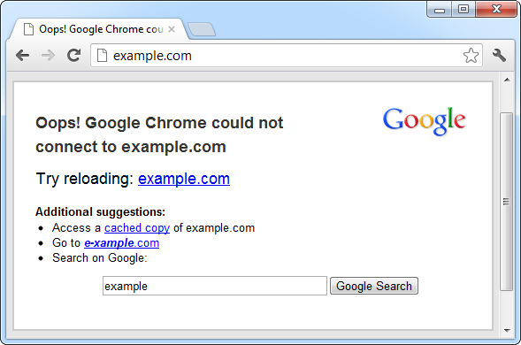

**Redirect a Website**

You can also use this trick to redirect a website to another website. For example, let’s say we want to redirect facebook.com to twitter.com – so when we type facebook.com into our address bars, we’ll end up at Twitter.

First, we’ll need Twitter’s IP address. To find it, we can use the [**ping command**](http://www.makeuseof.com/tag/8-dos-commands-memorize/) in a [**Command Prompt window**](http://www.makeuseof.com/pages/windows-command-prompt-commands-pdf) (click *Start*, type *Command Prompt*, and press Enter to open one). Type *ping twitter.com* into the command prompt window and you’ll see Twitter’s numerical IP address.[**The 8 Useful DOS Commands That You Should Memorize**](http://www.makeuseof.com/tag/8-dos-commands-memorize/) [**The 8 Useful DOS Commands That You Should Memorize**](http://www.makeuseof.com/tag/8-dos-commands-memorize/)[**Windows 7**](http://www.amazon.com/Windows-Premium-System-Builder-Packaging/dp/B00H09BB16/ref=as_at?tag=mak041-20&linkCode=as2) still features a command prompt window. so there's still a place for DOS commands. So for those of you that like the idea of typing in a few commands to avoid the hassle of...[**Read More**](http://www.makeuseof.com/tag/8-dos-commands-memorize/)

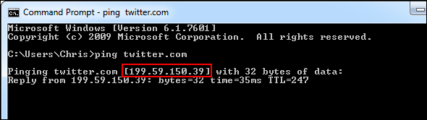

Now we can add the following line to our hosts file:

***199.59.150.39 facebook.com***

This line tells our computer to connect facebook.com to Twitter’s IP address. Type *facebook.com* and you’ll end up at Twitter!

**Create Website Shortcuts**

You can also use this trick to create “shortcuts” that quickly access websites from any program on your computer. For example, if you’re a [**Twitter addict**](http://www.makeuseof.com/pages/download-guide-twitter), you can associate “t” with Twitter – type t in any web browser’s address bar and you’ll instantly end up at Twitter. You can also create shortcuts with multiple letters, such as twit. You don’t need a .com, .net, .org, or any other type of extension. However, you can’t use spaces.

To do this, just add the following line to the hosts file and save it:

***199.59.150.39 t***

You can get the exact IP address you’ll need by using the ping command mentioned above.

Now you can type t into any program’s address bar and you’ll end up at twitter.com.

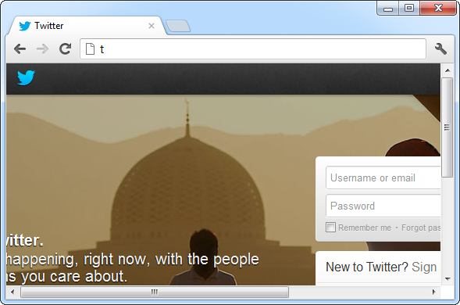

**Assign Local Domain Names**

You can also create local domain names for your computers. For example, if you have a local server that you use, you can name it *server* and quickly access it by typing *server* as the URL into any program. If you frequently access your [**router**](https://www.amazon.com/TP-LINK-Archer-C7-Wireless-Gigabit/dp/B00BUSDVBQ/ref=as_at?tag=mak041-20&linkCode=as2&)’s configuration page, you can associate the word router with your router’s IP address and type *router* into your web browser’s address bar to access your router.

Note that you’ll need the computer or router’s IP address before doing this. After you have it, enter a line like the following – the following line associates 192.168.0.1, an IP address commonly used by routers, with the domain name router:

***192.168.0.1 router***

You can replace the IP address and domain name here with anything you like.

**Test a Web Server That Uses Host Headers**

If you’re [**running a web server**](http://www.makeuseof.com/tag/set-apache-web-server-3-easy-steps/) on your local network, you may want to make sure it’s working properly before exposing it live on the Internet. Some web servers run multiple websites at the same IP address – the website you get depends on the host name you’re accessing. In cases like this, it’s not helpful to simply access the web server at its local IP address – you need to access it at its website addresses.[**How To Set Up An Apache Web Server In 3 Easy Steps**](http://www.makeuseof.com/tag/set-apache-web-server-3-easy-steps/) [**How To Set Up An Apache Web Server In 3 Easy Steps**](http://www.makeuseof.com/tag/set-apache-web-server-3-easy-steps/)Whatever the reason is, you may at some point want to get a [**web server**](http://www.bluehost.com/track/muo/) going. Whether you want to give yourself remote access to certain pages or services, you want to get a community...[**Read More**](http://www.makeuseof.com/tag/set-apache-web-server-3-easy-steps/)

For example, if you have a web server with the local IP address 192.168.0.5 that hosts websites for company.com and organization.org, you can add the following lines to your local computer’s hosts file:

***192.168.0.5 company.com***

***192.168.0.5 organization.org***

After saving the file, try to access both company.com and organization.org in your web browser – if everything is working properly, you should see the different websites. The server notices your headers specify company.com or organization.org and serves the correct website. If this doesn’t work, you have some troubleshooting to do before deploying the server on the Internet!

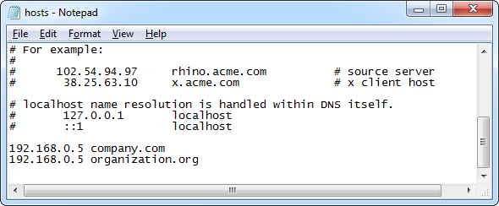

**Block Lists of Websites**

Some people create their own lists of websites they want to block and publish them online. You can block these lists of websites by copying one of these lists into your hosts file.

Check out the following article for some recommended lists you can use, along with a graphical tool that makes downloading these hosts files to your computer and using them easy:

* [How To Block Websites On Your PC Without Using Software [Windows]](http://www.makeuseof.com/tag/block-unsafe-websites-blocking-lists-windows-hosts-file/)

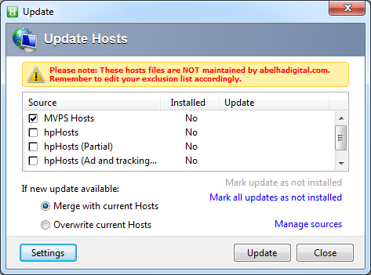

If you want to revert any changes you’ve made, simply delete the lines you added to the bottom of the file, then save the file.