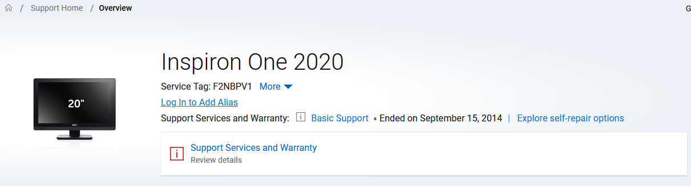

https://www.dell.com/support/product-details/en-us/servicetag/0-WS83c3ZGRGlxMWRULzFpY250UjY3Zz090/overview

