3 fixes for a dead Windows 10 Start menu

So much for the triumphant return of the Start menu. If it doesn't pop up for you, try these workarounds.

- Apr 11, 2016 3:28 AM
Pat Stuhlman was happy with Windows 10. Then, suddenly, the Start menu stopped working.
The return of the Start menu is probably Windows 10’s most popular feature. But it doesn’t work on all PCs. You can click the Start button, or press the Window key until Apple, Google, and Microsoft all merge together and switch to Linux, but the menu just won’t come up.
Here are three possible fixes. I can’t guarantee that any of them will work, but hopefully one will.

1. Fix corrupted files
If the Search bar still works, search for powershell. Then right-click Windows PowerShell in the search results and select Run as administrator.
But if the search bar doesn’t work either, press Winkey-R, type powershell, and press Enter. Right-click the PowerShell icon on the taskbar and select Pin to taskbar. Close the PowerShell program. Hold down Shift and Cntrl while you right-click the PowerShell icon again. Select Run as administrator.
Once you’re in the Powershell command-line environment, type the command sfc /scannow and press Enter. Then wait. It can take quite a while.
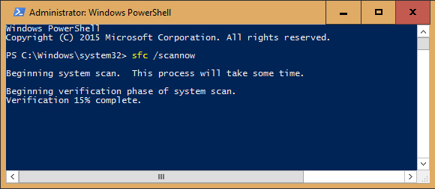
Eventually, the program will tell you either that it found no corrupt Windows files, it found and fixed them, or it found some but couldn’t fix them. If you get the latter response, try the command
dism /online /cleanup-image /restorehealth
This should (hopefully) download replacement files.

2. Remove and reinstall your Metro/Modern apps
Relax. This isn’t as bad as it sounds. First of all, this only effects the Metro/Modern/Windows 10 apps that you get through Microsoft’s Store. Old-fashioned Windows programs won’t be affected.
Second, it’s all automated.
Open PowerShell as an administrator as described above. Type in the following command—or better yet, just copy and paste it:
Get-AppXPackage -AllUsers | Foreach {Add-AppxPackage -DisableDevelopmentMode -Register “$($_.InstallLocation)\AppXManifest.xml”}
When it’s done doing its job, reboot.

